How to check Rx rate and Tx rate?
Step 1: Open the browser and input plc.tendawifi.com in address bar to login setup page. By default, password is “admin”.
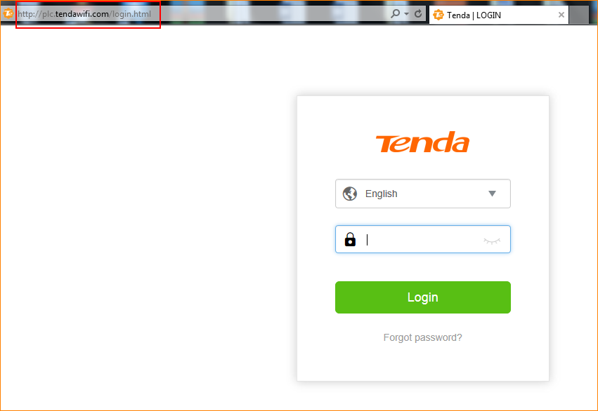
Step 2: Choose “Powerline” > “Powerline Device List”.
